Castel Maggiore, 24th May 2007
To all our customers

SUBJECT: NEW SEQUENTIAL SYSTEM SOFTWARE “UPDATED”

We uploaded today on our internet website, an updated version of the new software for sequential system (version 5.0.0.1 C).

This version corrects one character visualization defect that we noticed with SOME personal computers.
The software 5.0.0.C does work properly anyway. Just the visualization of the screen could be different from one PC to another one.
With the new version 5.0.0.1C this will not happen.
The correct visualization is as shown here below:

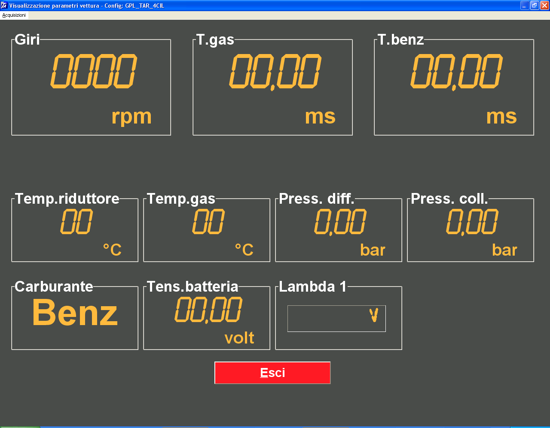

We remain at your complete disposal for any further information or clarifications.

Best regards

TARTARINI AUTO SPA

